**Creating order**

* partner login with direct or proxy url
* But when creating order we need to access direct URL
* Using partner login create a quote
* -After submitting quote if buy method is cisco i.e., 1-tier we can create an order using parner login with username and pwd in direct url (or) if buy method is "disti" i.e., 2-tier we can create an order using disti login with username and pwd in direct url
* Another way we can login as AM in SFDC and create opportunity
* partner should be required
* if buy method is cisco i.e., 1-tier we can create an order using partner login with username and pwd in direct url (or) if buy method is "disti" i.e., 2-tier we can create an order using disti login with username and pwd in direct url
* There are 2 engines like CG1 and OPL
* Based on line types it will either call “CG1” or “OPL(Order Processing Layer)”
* If line types are product and services then those items goes to CG1 and CG1 will take care of shipping ,to change status in quoting or order or verify whether end-customer address is correct or not
* If line types are subscriptions then this OPL layer will take care of
* In subscription there will be requested start date lets say 1 jan 2018 and on 31st dec 2018 this OPL sends this order to SBP—will take care of activating the licence for subscription

Example

* Suppose we created an order for subscription “a-wx-ports” it comes to OPL and before 24 hrs it requested start date right so that details will be sent to SBP and SBP will activate and will take care to fulfill this order and creates Subscription_ref_id
* Subscription_ref_id will be stored in CC_QUOTE table

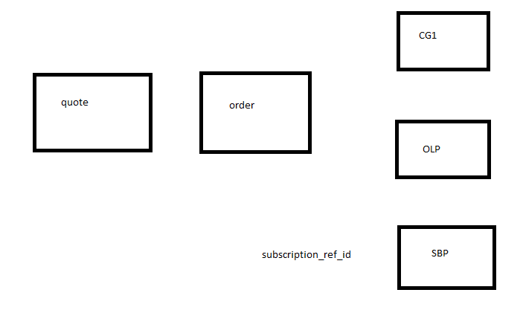

* Subscription items will have initial term and auto Renewal Term. Let’s say initial term is 12 months and auto Renewal Term is 12 months.
* After 12 months got completed he wants to change that order i.e., he wants to increase the quantity or decrease the quantity whatever change it may be or he wants to add additional minor items for this subscription. To do that we have some process which is called as “Change Subscription”.
* Let’s see how to do that

Subscription URL: https://ccrc-sc-stg.cisco.com/subscriptions-main/landing/?

Credentials: imdisti/ cisco123

* We can login using partner /disti
* That means we can remember only partner/disti can create order

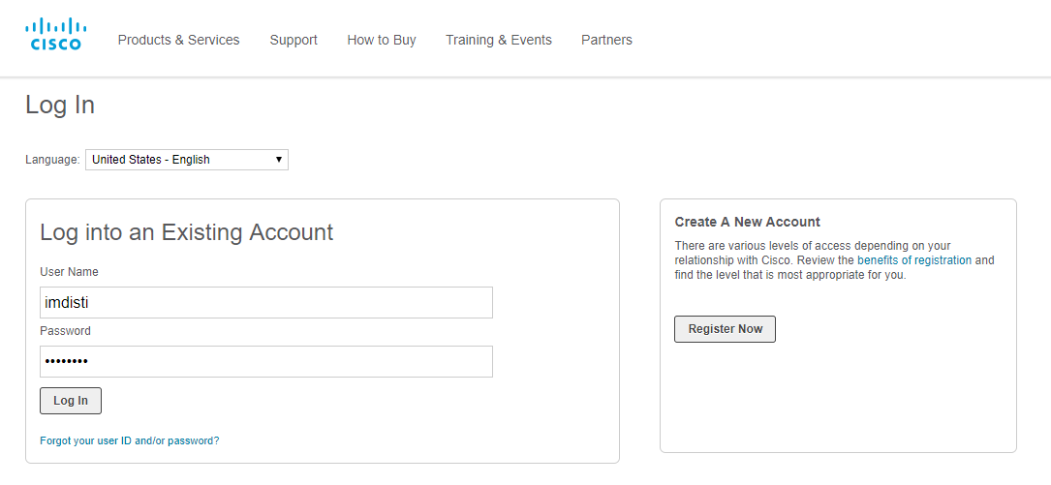

* To access this subscription url remove the proxy from network proxy settings

i.e., *.cisco.com

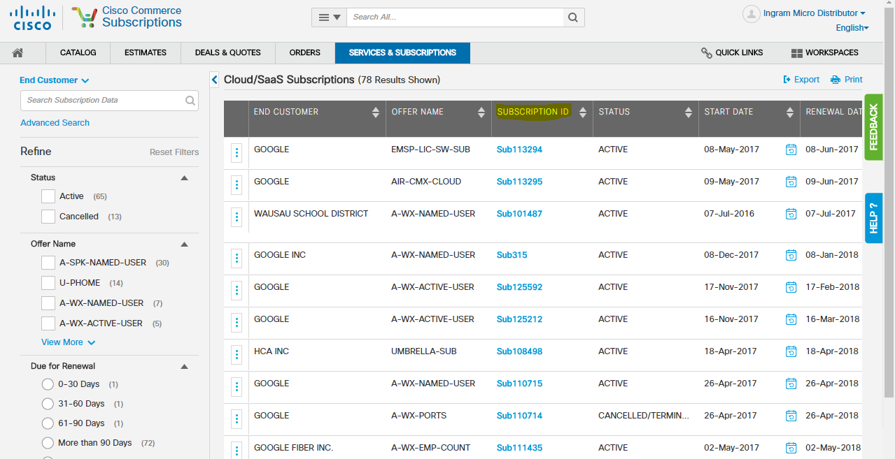

Here in pic SUBSCRIPTION ID is nothing but subscription_ref_id.If u click on particulat subscription id

You will get following information about that subscription(here we selected A-WX-ACTIVE-USER

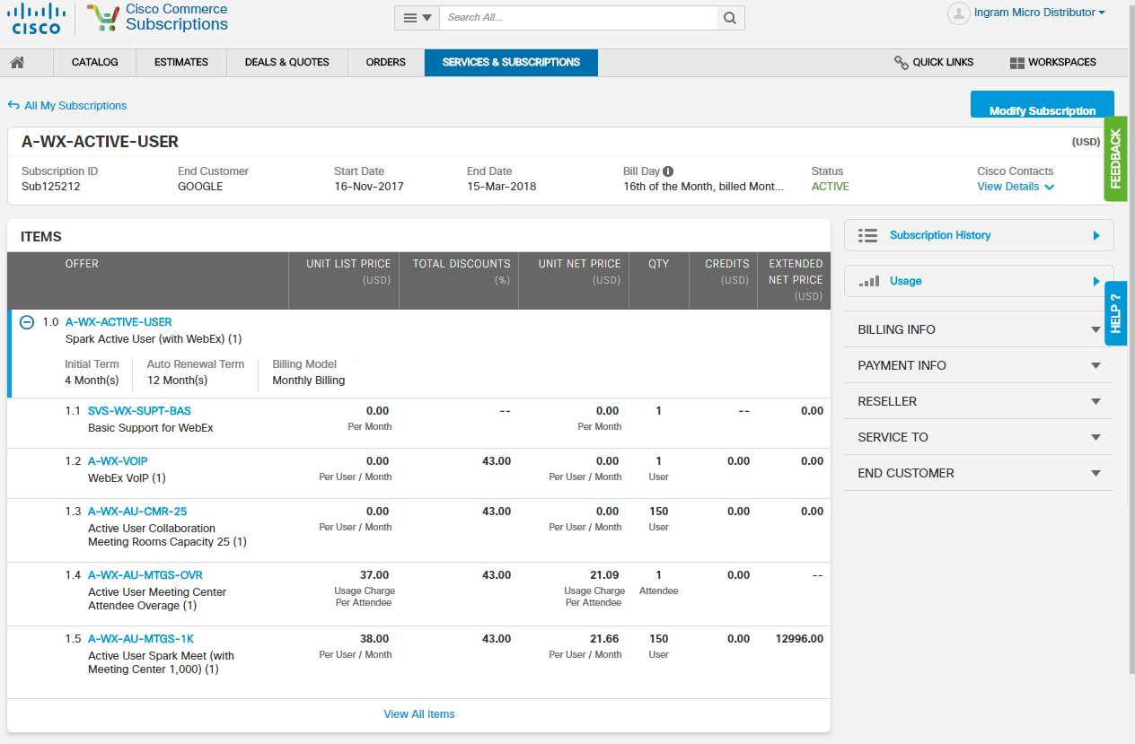

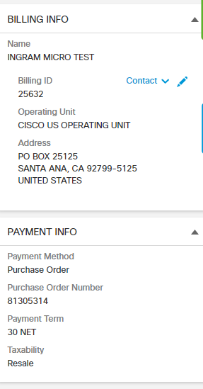

We can see Billing and payment Info as shown above

If you click on subscription History right side like below



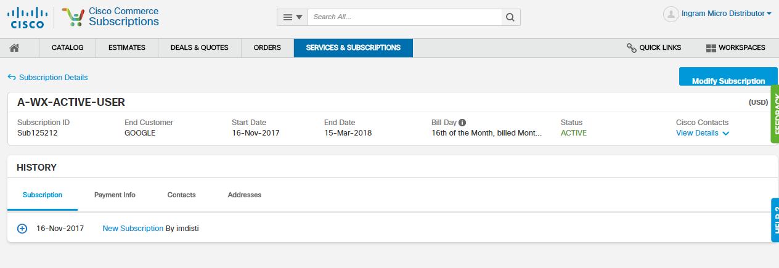

If we expand it subscription details will be visible

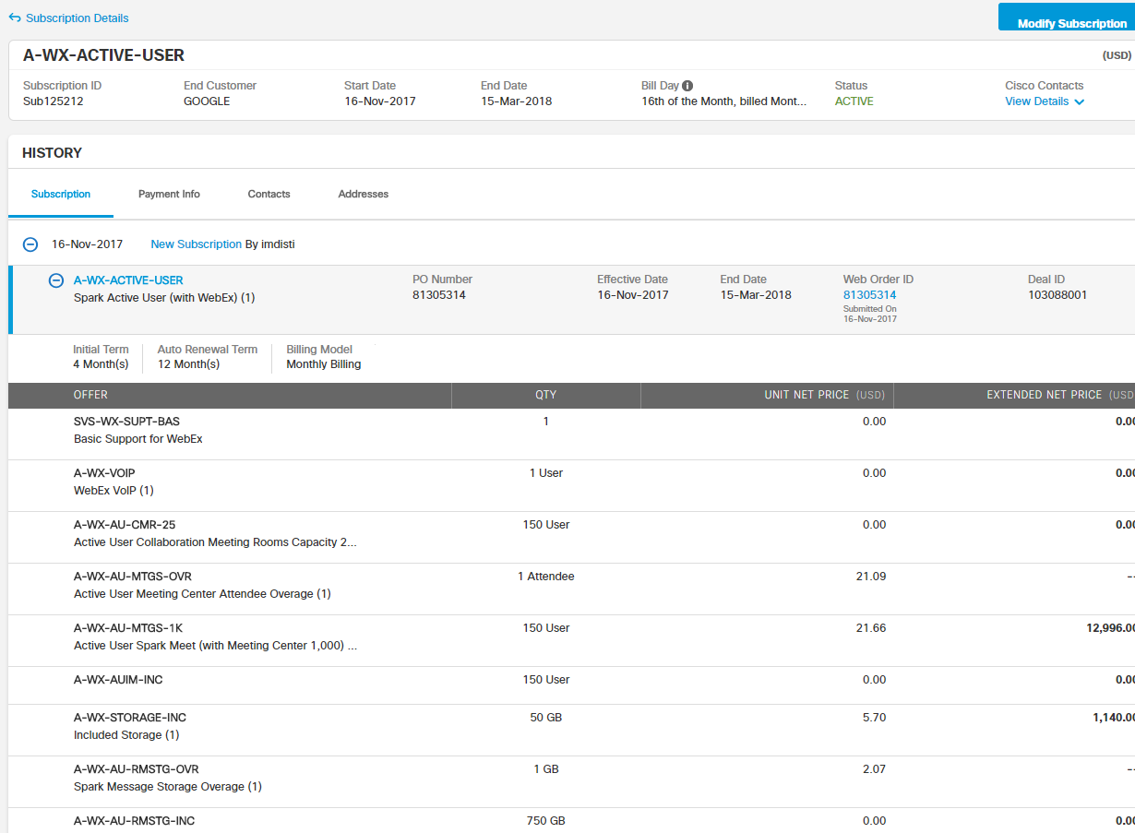

Expand the subscription like above

Web order id will be created when we create an order

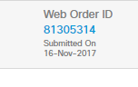

Go back to --🡪all subscriptions 🡪click on blue dots-🡪click “Modify Subscription(this is what initiating the change subscription)🡪it will take us to CCW

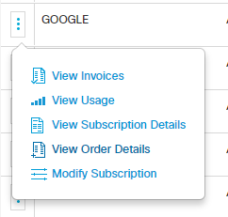

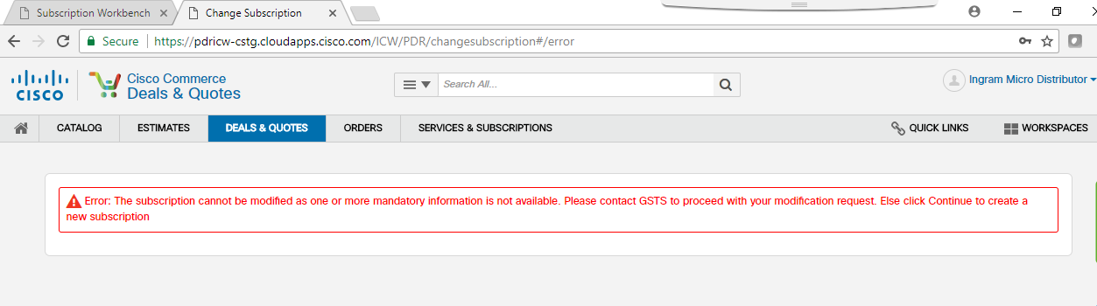

It will give above error like  


So for now select another subscription which is not showing error

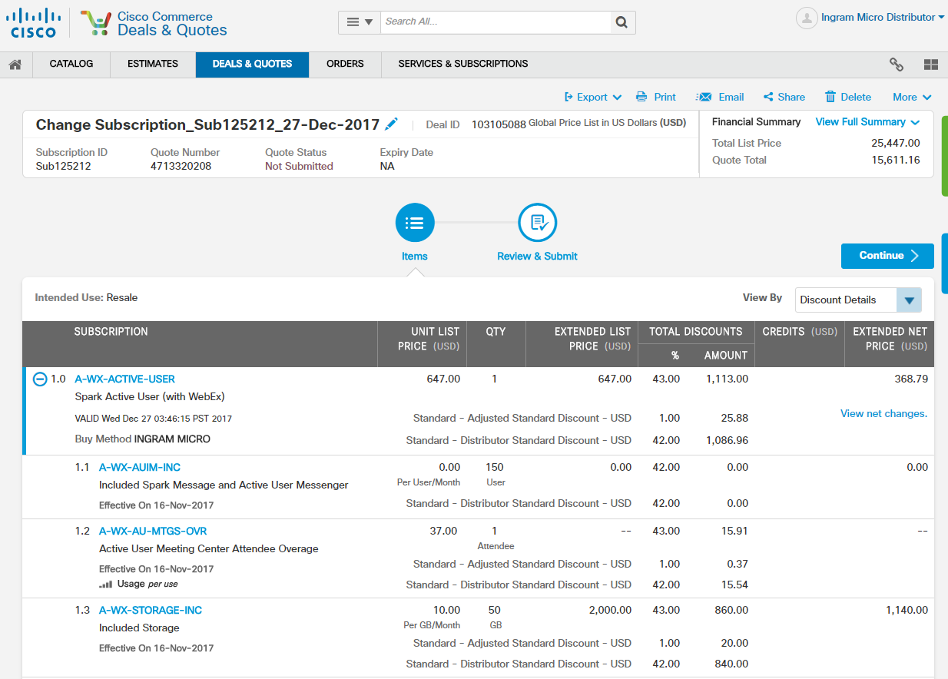

This is CCW URL and it is CCW Quoting but UI will be different

We will see this UI only for “Change Subscription”. There will be only 2 pages

1. Items 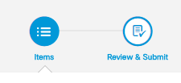

2. Review and Submit

If u login as AM then “Qualification page” also visible

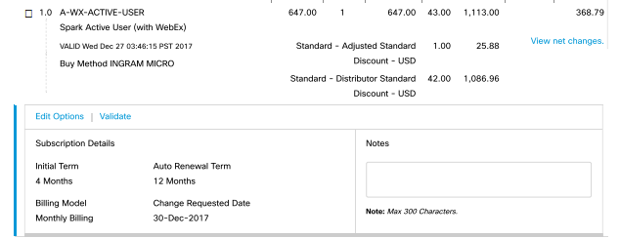

When we initiate a subscription a “New Deal” will be created

Ex: A New Deal for above change subscription is = 103105088

When we initiate a subscription a “New Deal” will be created.

So if you want to reconfigure it /change it we can change it for that there will be “Edit options”

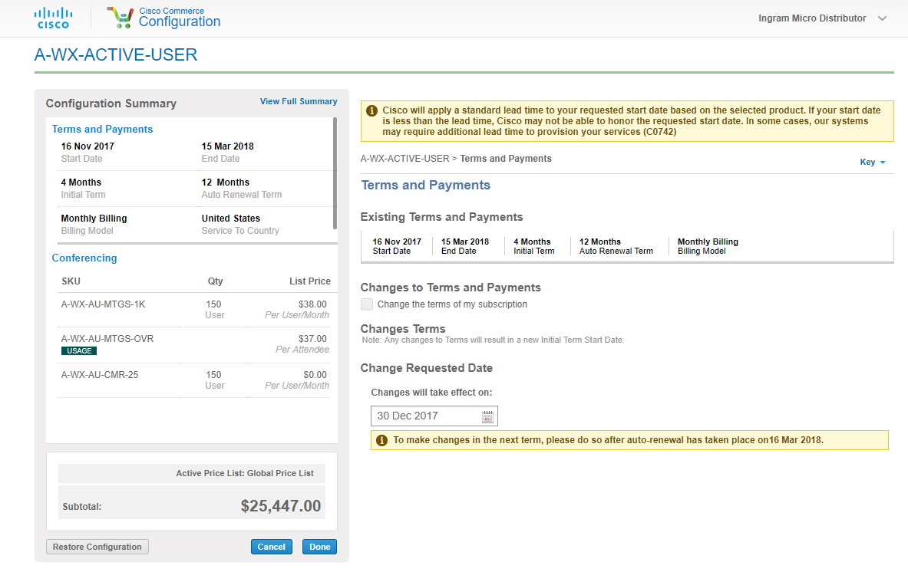

* so we can change the requested start date and all
* we can remove /add any SKU’s if we want
* and after u configure based on the requirements then just click “Done”
* Then click “continue “as below

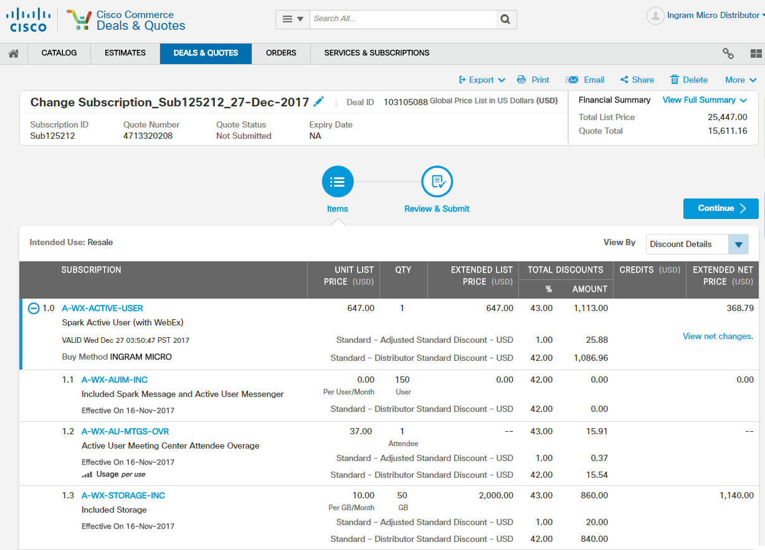

Click “submit” as below

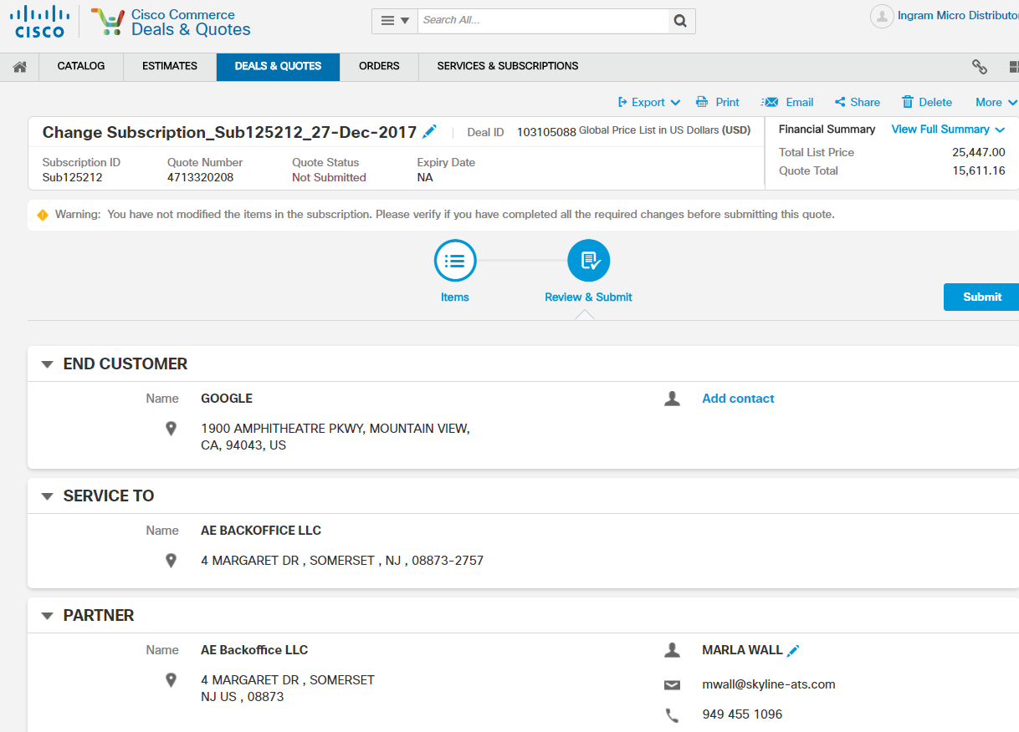

So now we initiated Subscription on top of this “Subscription Id”

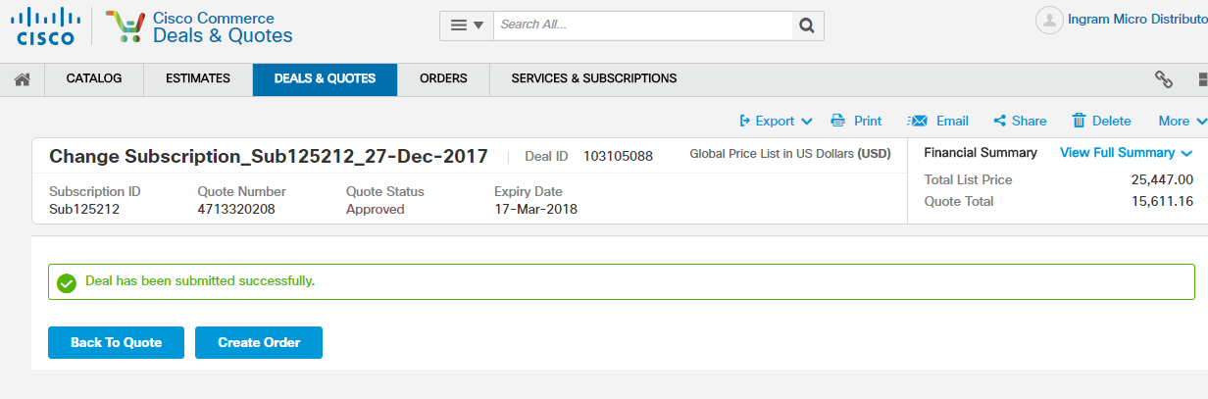

After all completed like after “creating an Order” and all and if you go to “subscription history” another record will be there which is for “New Deal” that we created i.e., 103105088(new deal)

This is how we initate a subscription

Note:

So for new deal the subscription deal will be “source Deal id”

Note :

The subscription id shown below

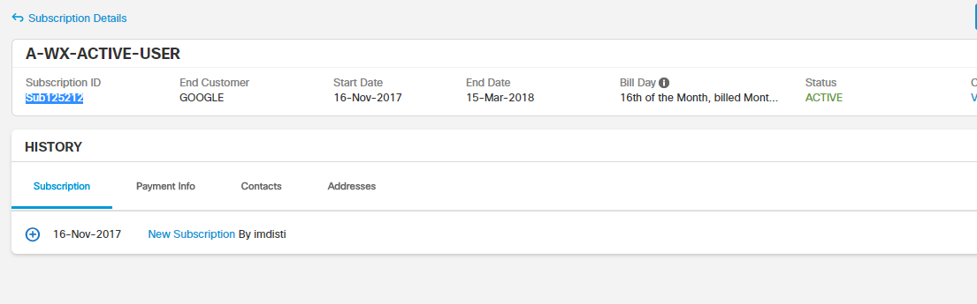

So when we initiate a chain subscription we create a deal and added this item and ordered this item so that “Web Order Id” for that item and SBP gives us this subscription id “sub125212” as shown below

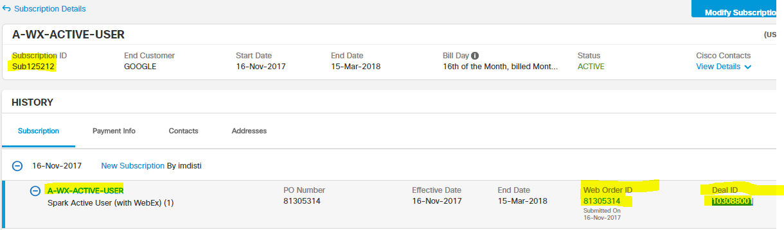

Now we initiated a change subscription on top of this subscription id i.e., sub125212 and we got a new “Deal Id” as 103105088

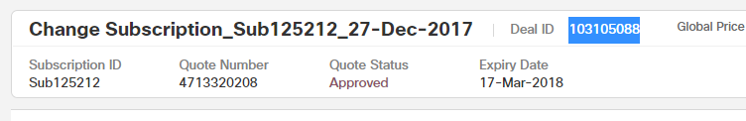

Note: Now-a-days most of the action items that we get from onsite will be related to this “Chain subscription” only bcoz it’s a new UI and there are some issues in that.so they will tell you to get this source id’s for this Chain subscription Deal Id’s and all.This is how we can find in UI and in backend also data stores(will discuss)

**Webservices**

* we will get data from config and pricing
* we will exchange data through web services
* those external webservices are mostly logged in “Kibana3”
* “Kibana3” is an application where we can have idea about all the web services that our application calls
* Lets do it
* Create a quote using disti login
* Select partner as follows

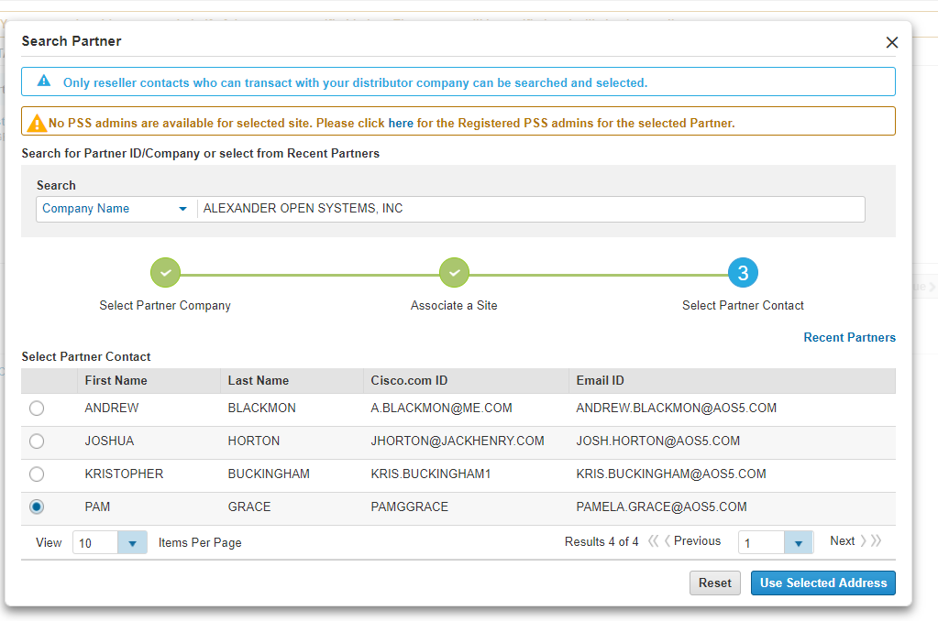

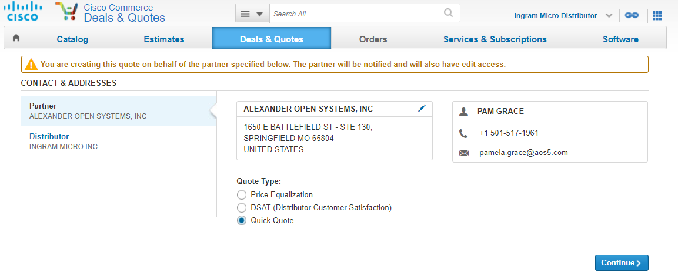

* Click continue

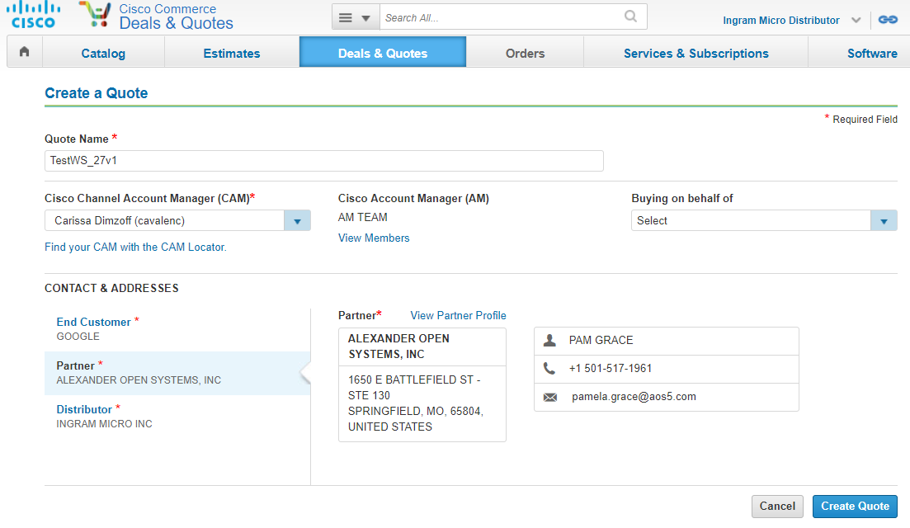

* Click create quote



Above Quote Number will be the Quote ID i.e., 4713320971

* If we search based on this “Quote Id” in Kibana ( in Discover)---last 15min
* It will show all available web services that an application calls
* 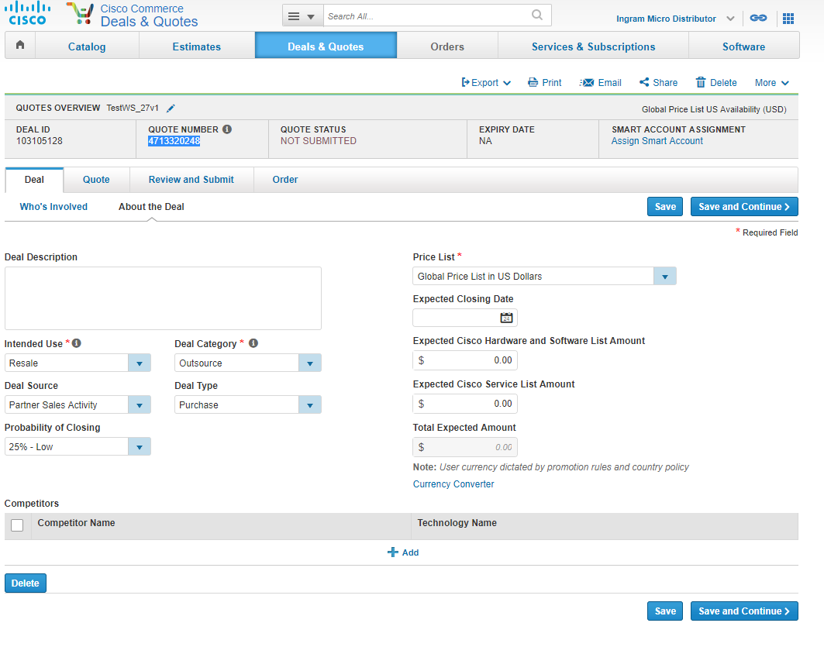
* Click “save and continue”

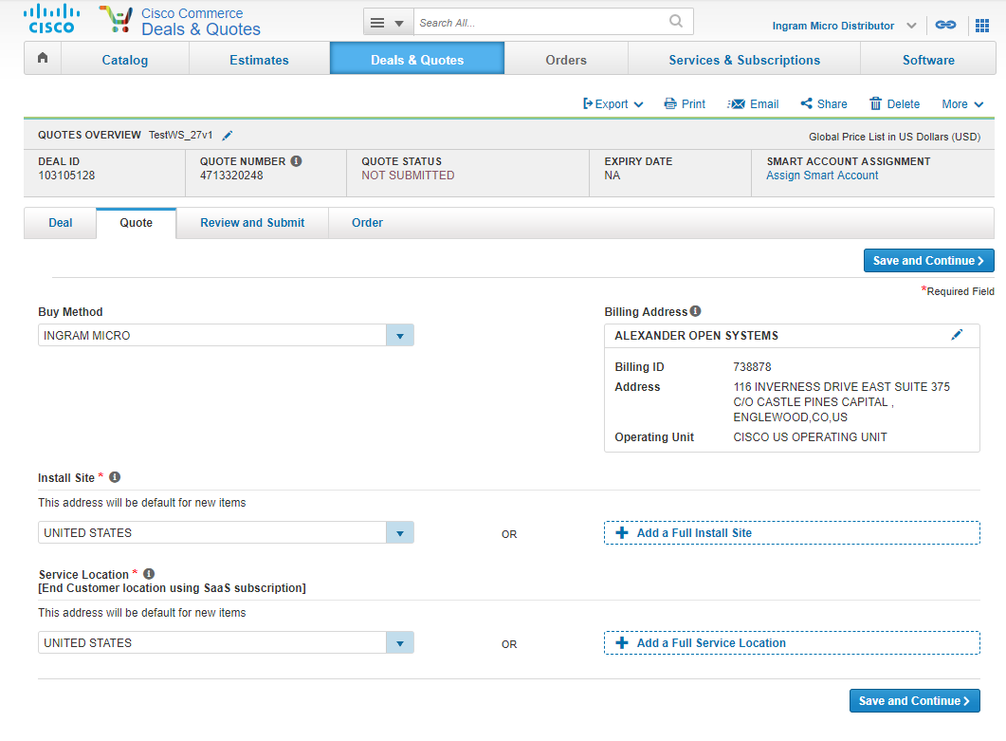

* Buy method “INGRAM MICRO” and click “save and continue”
* Now u can check in kibana whether any web service is getting called or not with quote id “4713320248”
* Now add item UCS
* 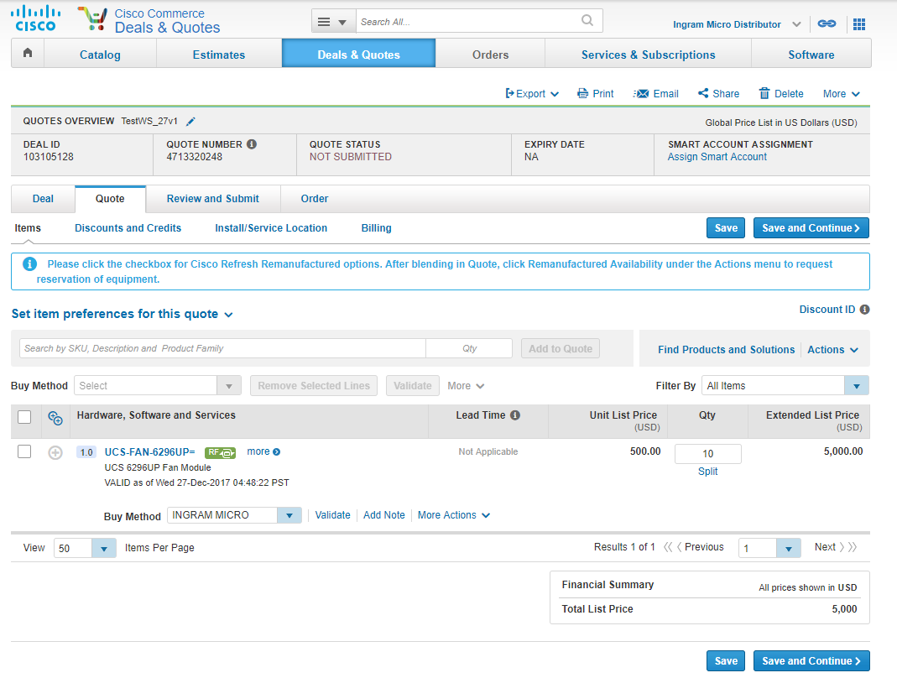
* Click “save and continue”
* Now check for web service calls in kibana using Quote Id : 4713320248
* –web service called when quote is created

1. Quote Creation (Direct URL using imdisti login)

1. Web service call after creating quote

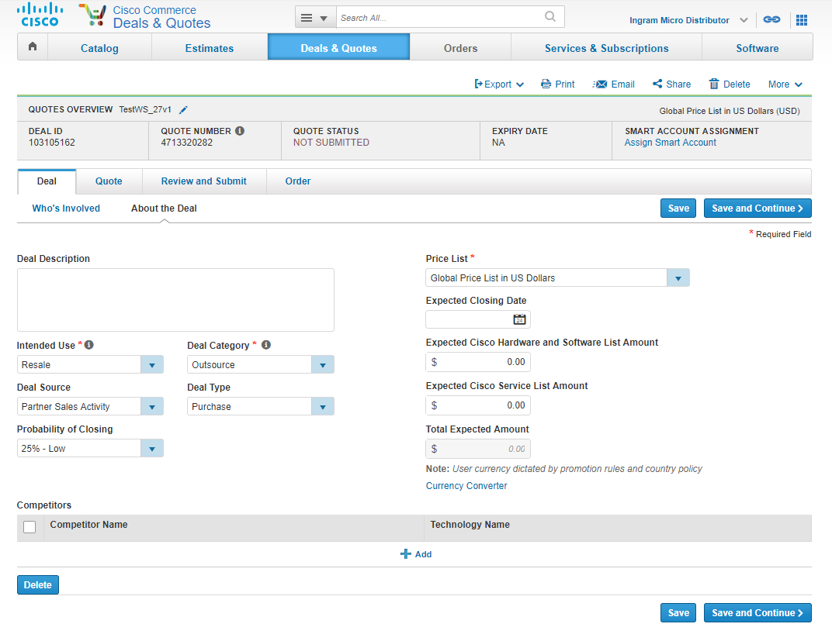

Web services called in kibana as follows

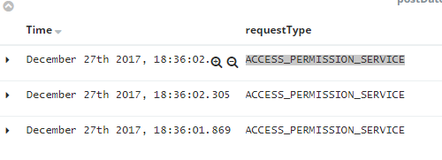

----ACCESS_PERMISSION_SERVICE: After creating quote

2. Web service call from about deal to quote page

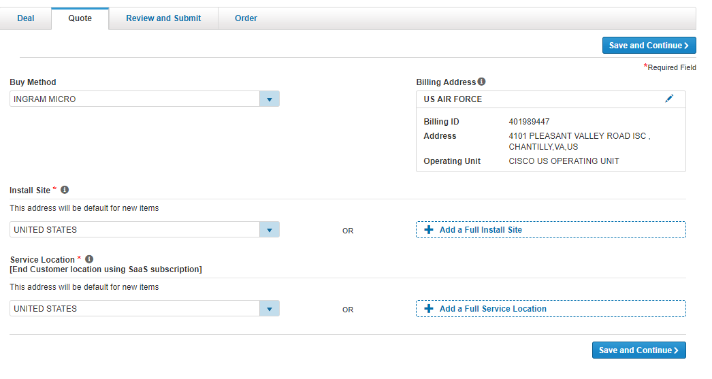



------ACCESS_PERMISSION_SERVICE: about deal to quote page

2. Quote----Items

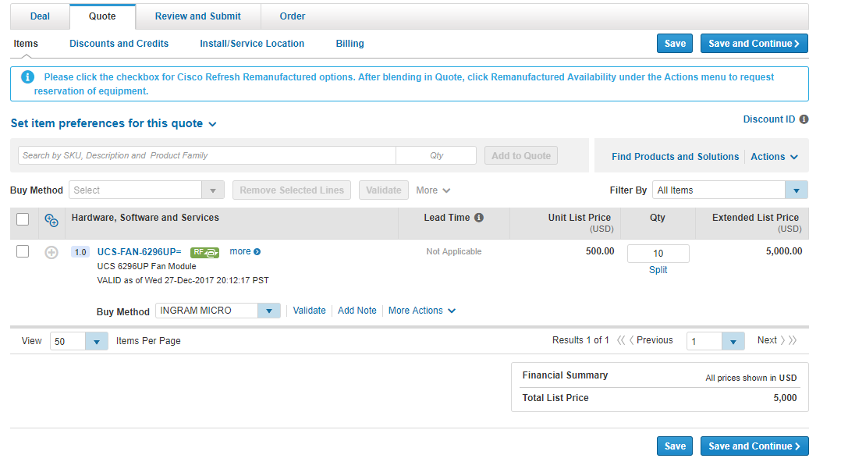

web service call after adding product item

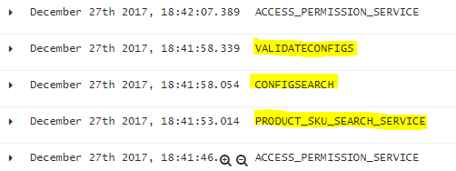

Note:

For kibana uncheck the below box

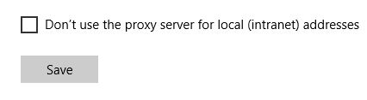

-----PRODUCT_SKU_SEARCH_SERVICE—if we expand this service as below we can see requestXml and responseXml (these can be in json or xml format)

---- CONFIGSEARCH

----- VALIDATECONFIGS

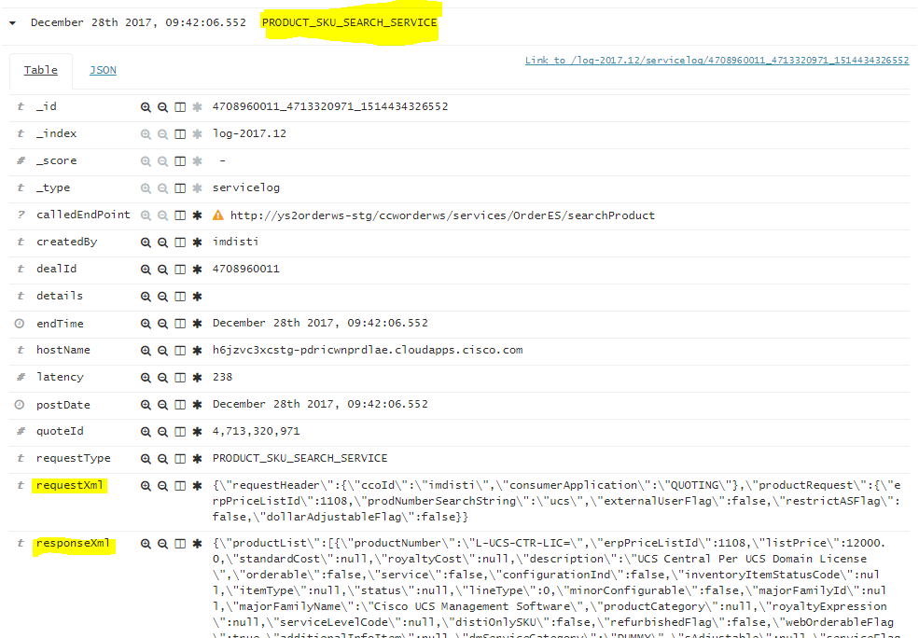

requestXml

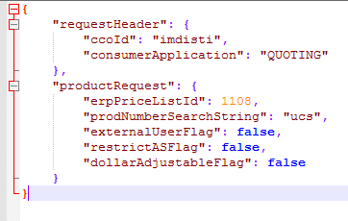

responseXml

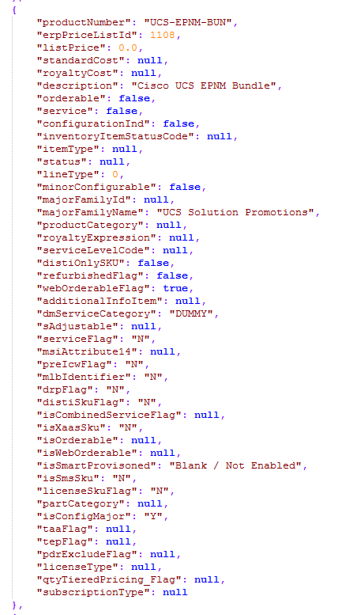

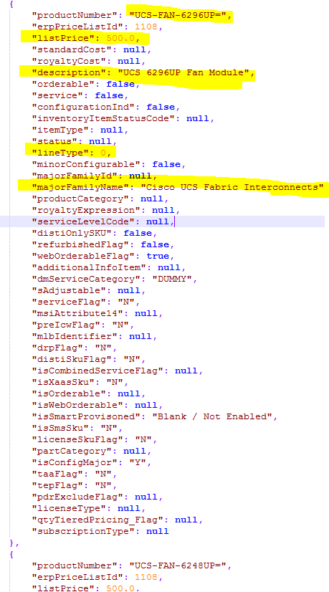

So “PRODUCT_SKU_SEARCH_SERVICE” is for “List of Items options”(bcoz when u type “ucs” it will display list of item options so)

Note:

To add json and xml plugins in notepad++ download jsonviewer and XML Tools and copy the .dll files in c:\program files(x86)\notepad++\plugins folder and check in notepad++ plugins tab u can see the plugins installed

2.sometimes we get requirement from client to get request and response xml from services then we need to do like this

----

CONFIGSEARCH web service –we selected the following product and will send to config team

requestXml:



Then config sends back some response

responseXml:

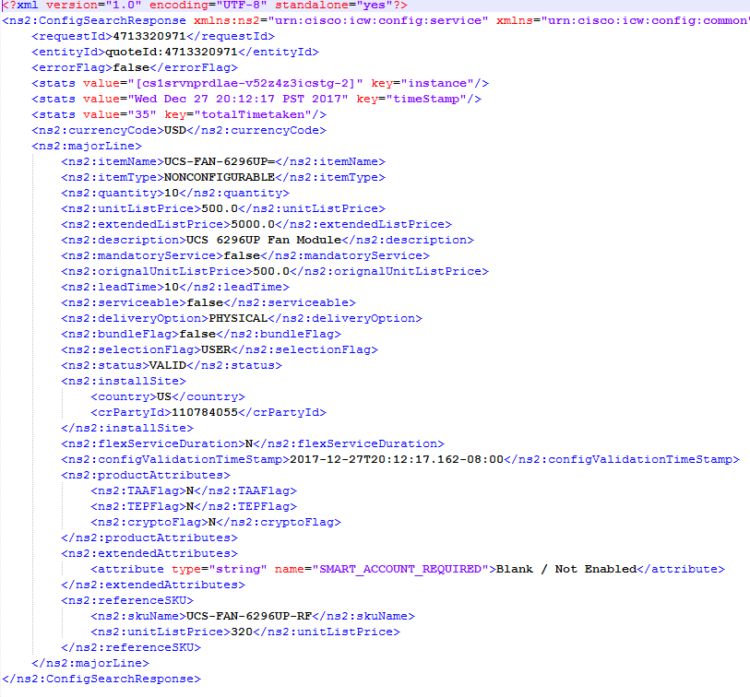

CONFIGSEARCH service returns “selected Item details from config as above”

VALIDATECONFIGS service

Whatever the item we selected and send to config to verify if it is valid or not, the config will send response “VALID” if it is valid or “INVALID” if it is not valid

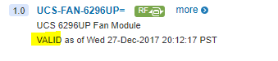

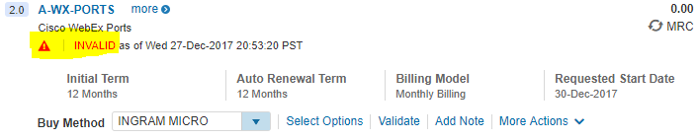

If we see response Xml in webservice we get “Product config error”



3.Quote-🡪Discounts and Credits

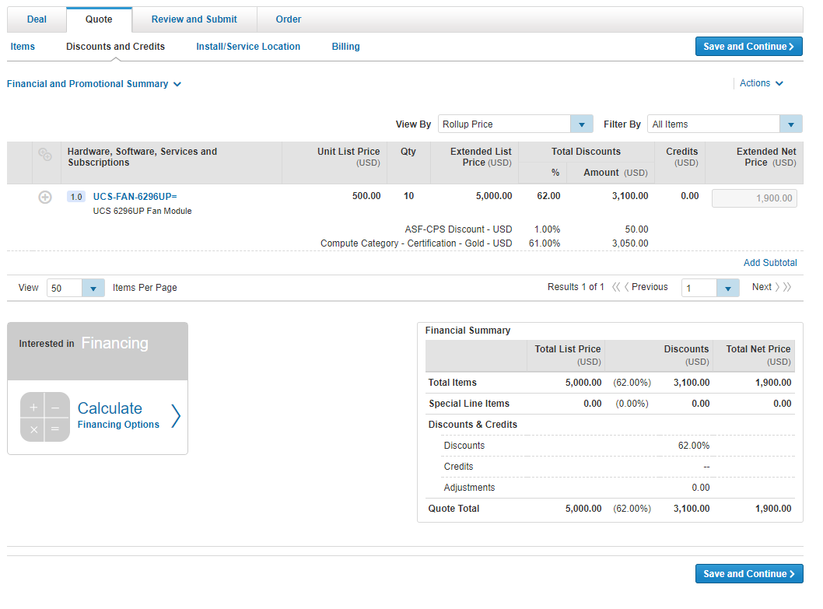

Webservice calls are:

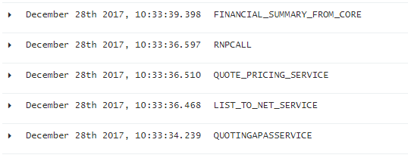

* QUOTINGAPASSERVICE ---- this gives success response(to verify all the web services are called)
* LIST_TO_NET_SERVICE ---this is main service which contains all discount details(to get pricing details)

Request xml

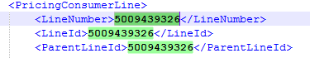

This is the Line object Id i.e., every line will have an Object Id

Response Xml

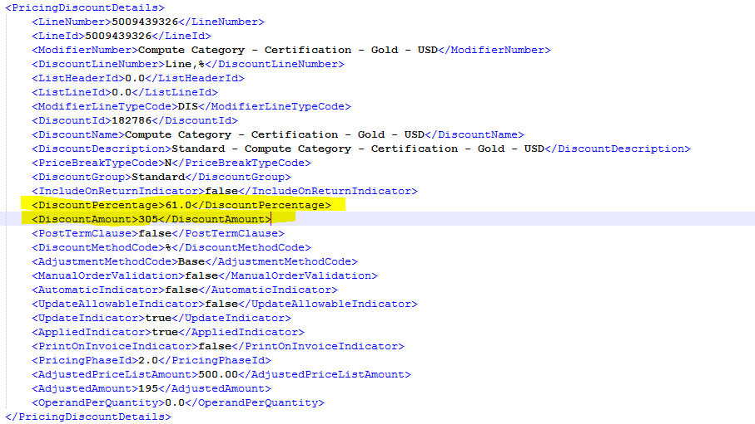

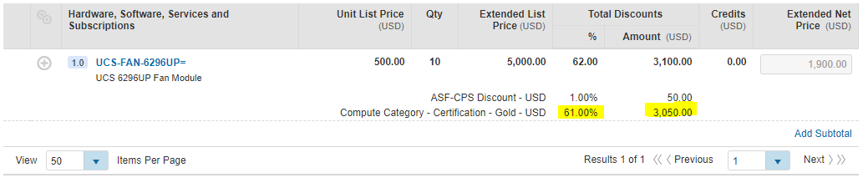

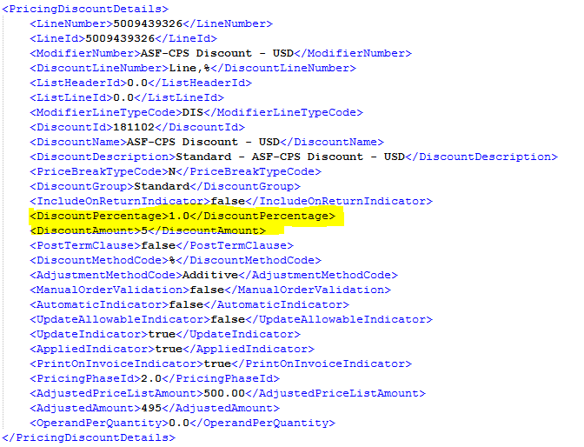

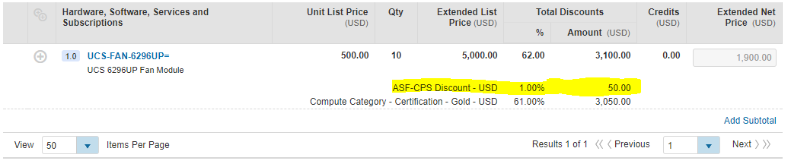

Note:

Extended Net Price and all will be calculated in CCW itself

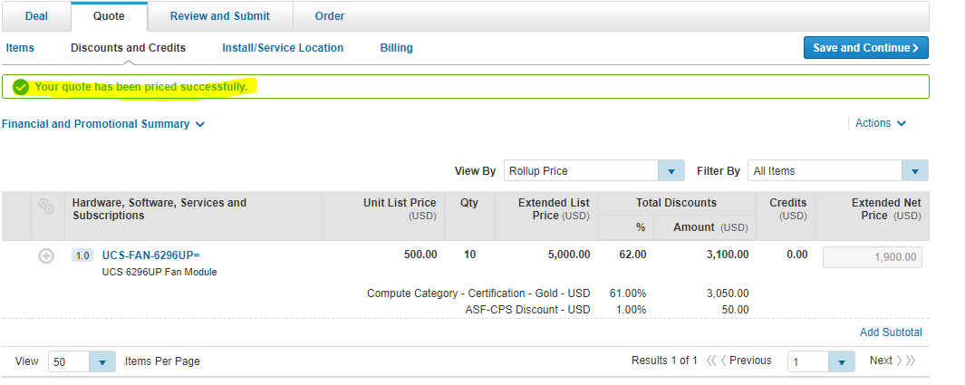

* QUOTE_PRICING_SERVICE

This is just to show quote has been priced successfully message



* RNPCALL

If we login as AM there will be another column “Effective discount”.so there u can edit Effective discount or Effective Net price. So if we edit that amount then RNP will be called. This means “Recalculate Net Price(RNP)”

This is called when discounts/net price is changed

* FINANCIAL_SUMMARY_FROM_CORE

This service give full information about “Financial Summary” block details

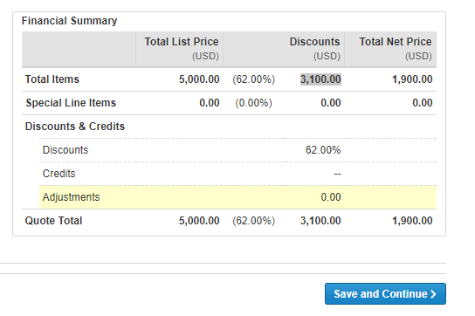

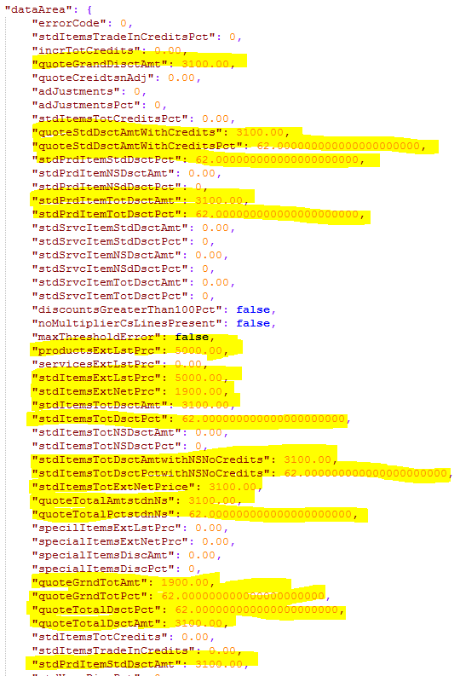

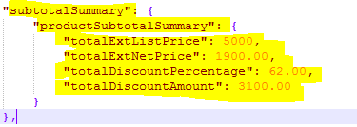

Service response

Now lets go back to items and add subscription in items



So here by clicking “Edit options” it will take us to “Config UI”

So here Lets check in kibana what web services are called when we go to Config UI

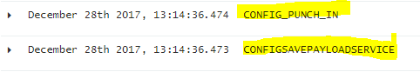

1. CONFIGSAVEPAYLOADSERVICE

---This service will be called when item details are passed to config

1. CONFIG_PUNCH_IN (means entering into Confug UI)

---This is just Wrapper to above service

---config_punch_in will call the above service to create the request xml and pass it to config

So now we added SKU’s or items to subscription above (which is invalid)in Config UI

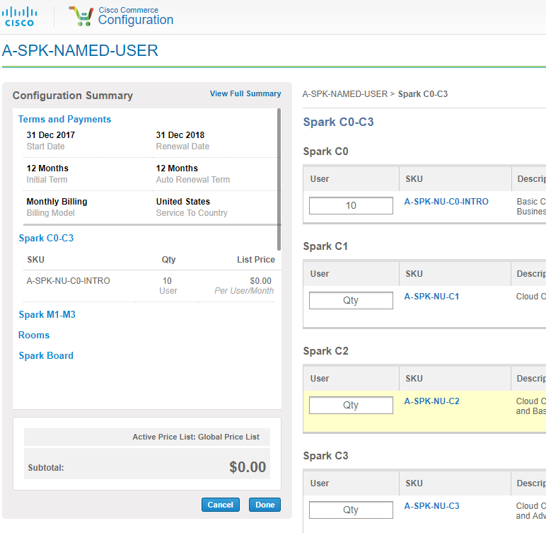

And after all done it we will return back to CCW again which becomes valid subscription after adding some SKU’s to it

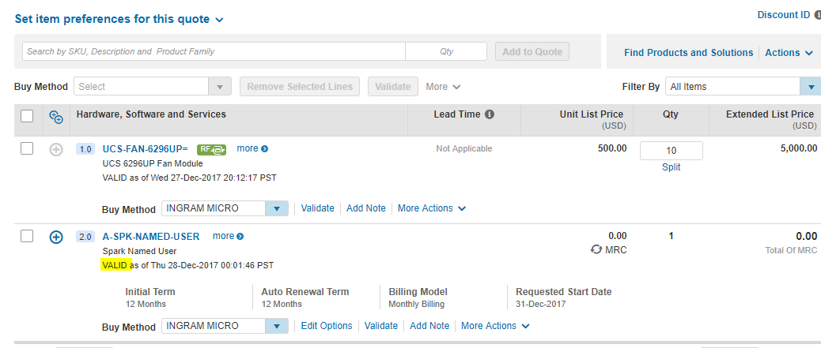

1. CONFIG_PUNCH_OUT (means coming out from Confug UI)



When we return back to CCW page after all done in Config UI then CONFIG_PUNCH_OUT web service will be called

Response xml :

It contains configured item details I.e all minor lines in response page

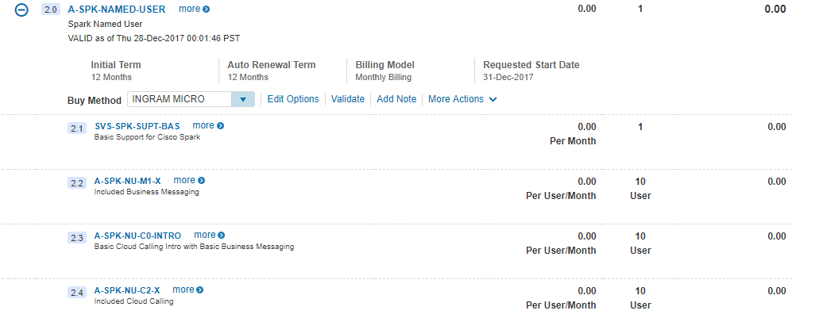

* CONFIGSAVEPAYLOADSERVICE and CONFIG_PUNCH_IN:These2 are request xml
* CONFIG_PUNCH_OUT : response xml

**Note**:

The important web services are as follows:

* ACCESS_PERMISSION_SERVICE: About deal to quote page
* PRODUCT_SKU_SEARCH_SERVICE: List of item options
* CONFIGSEARCH: selected item details from config
* VALIDATECONFIGS:to check item is valid or not
* CONFIGSAVEPAYLOADSERVICE:item details passed to config
* CONFIG_PUNCH_IN:wrapper to above service
* CONFIG_PUNCH_OUT:configured item details along with minor lines
* QUOTINGAPASSERVICE: to verify that all web services are called
* LIST_TO_NET_SERVICE: to get pricing details
* QUOTE_PRICING_SERVICE:to verify if pricing calls were made successfully
* RNPCALL:Recalculate Net Price
* FINANCIAL_SUMMARY_FROM_CORE:Financial summary block details

Above 5 are most called web services

Response mail contains major lines and minor lines details as below

Major line

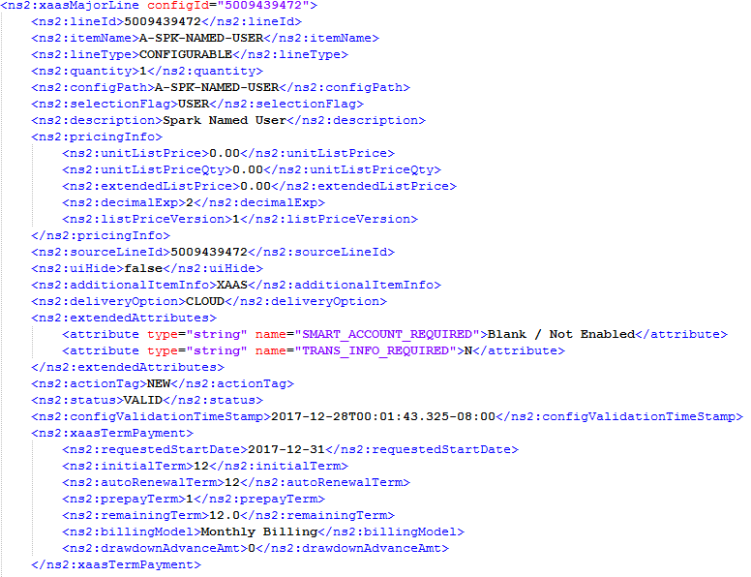

Minor lines

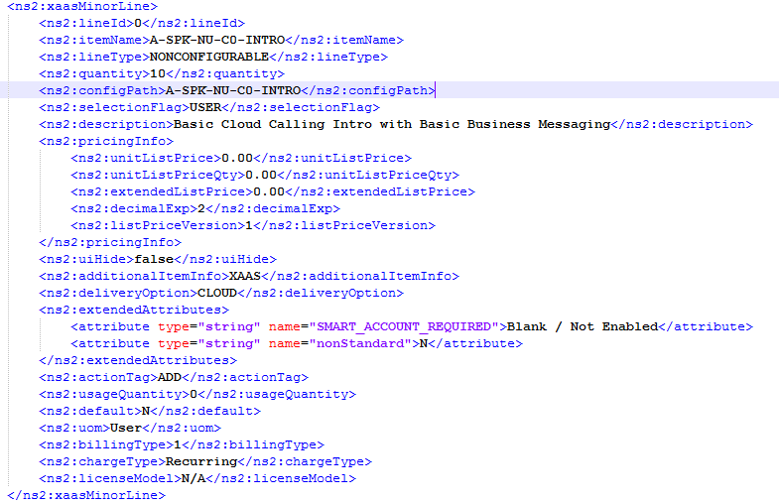

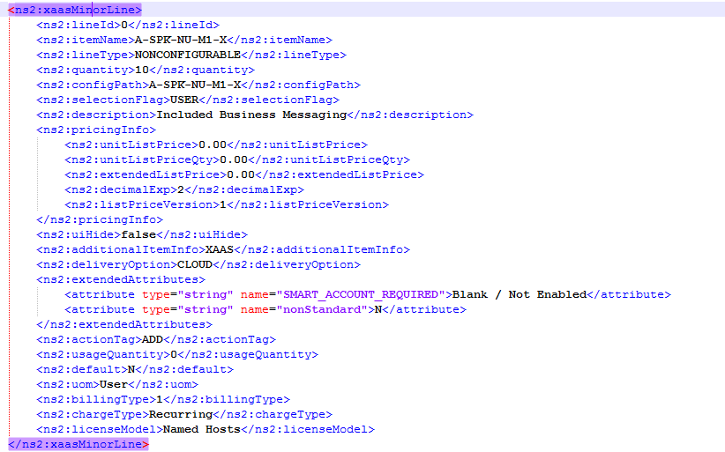

And so on.. as shown in CCW page minor lines

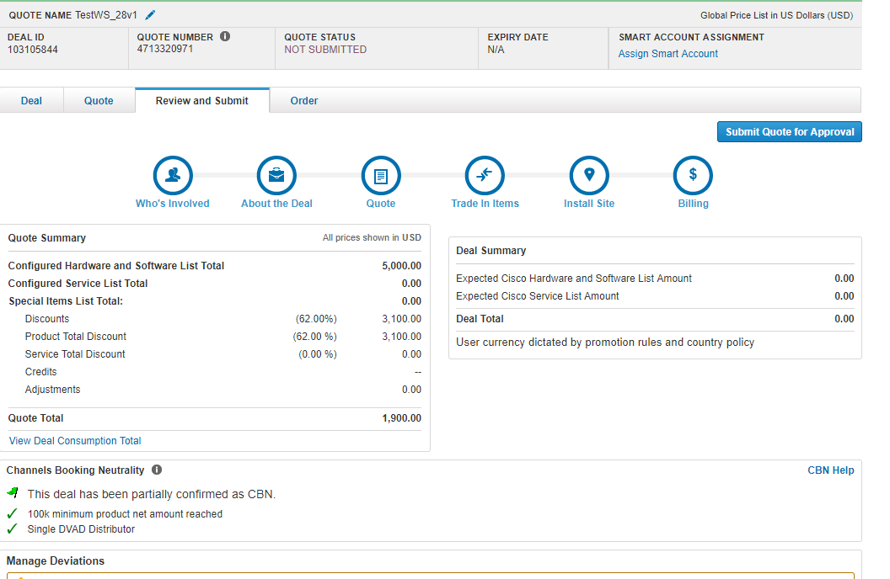

In review and submit page, the web services will be called are:

* VALIDATECONFIGS:to check item is valid or not
* SCORE_SERVICE:
* FINANCIAL_SUMMARY_FROM_CORE:Quote summary

After submitting order, the web service called are:

* CALLQUOTEORDERSYNCSERVICE

**Database Tables (Toad)**

* We work on testing environment, it is called “TS3DMP”
* For this quarter it will be “TS3DMP(database)”

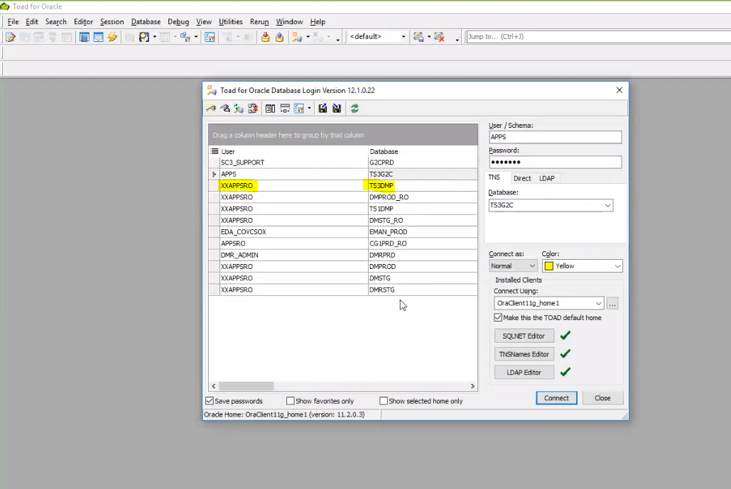

* For next quarter it will be “TS1DMP(database)”------( in above diagram)
* Production environment “DMPROD_RO(db)”--------(in above diagram)
* For stage “DMSTG_RO(db)”----------( in above diagram)
* We logged in as user i.e., “XXAPPSRO” they didn’t give us App schema pwd this read only(XXAPPSRO@TS3DMP[3])
* We have to work in Read-Only(RO) schema only (RO->Read-Only)
* There is “DMADM” this is main schema name and there will be synonyms for schemas
* Proxy url and all that we worked till now that all points to this “TS3DMP”.
* 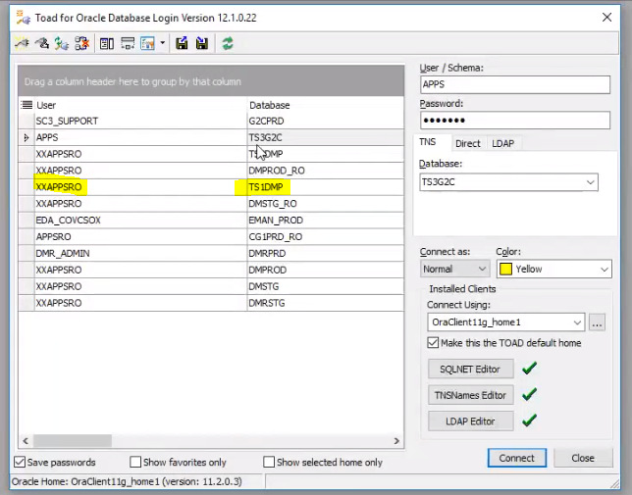

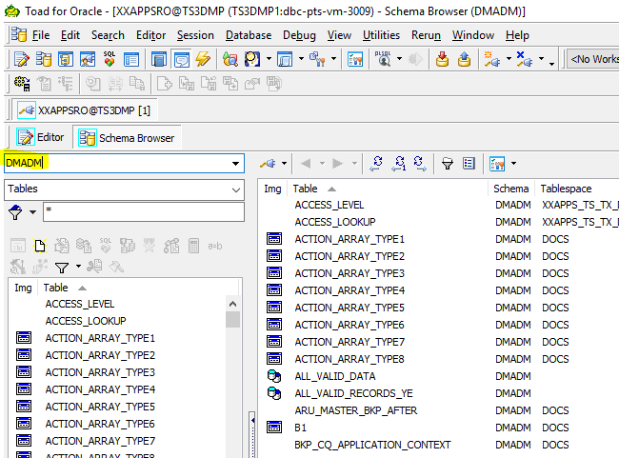

* Most of the tables in Quoting starts with “cq*(all tables related to quoting)”

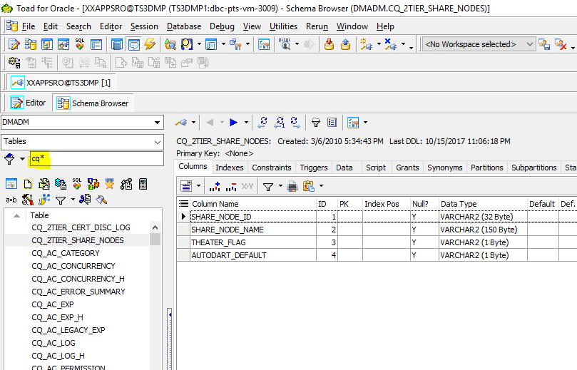

* So the main one will be “CQ_DEAL” table

**Query:** select * from CQ_DEAL (this query will have deal level details)

**Ex:**

We created a deal using

Direct URL: <https://pdricw-cstg.cloudapps.cisco.com/ICW/PDR/home.do>

Username: imdisti

PW: cisco123

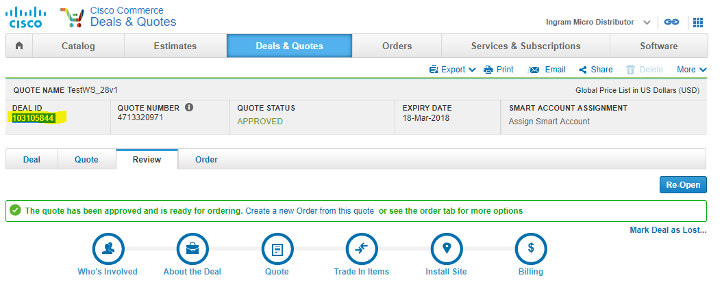

In backend we call this “Deal Id” as “opty_number”

Ex: select * from CQ_DEAL where opty_number='103105844'

Sol: all deal level details of that particular Deal id=103105844

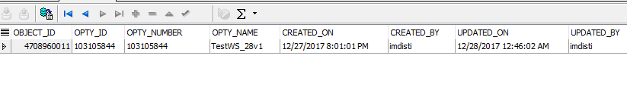



* The above **object_id** is a unique identifier for this row
* In the main page of CCW we have 2 options like

Create deal

Create quick quote

So to know that whether we created deal or quote

We can click on 3 lines i.e. It will display all columns



So there is a column called “DEAL_OR_QUOTE” by clicking that we can able to see the result.

So above we can see “Q”, it means that it is “standalone quote”

* To know what type of deal it is there is column “DEAL_TYPE”



So the created deal is a deal of deal type-3

* there is another table to know what exactly this Deal type-3 is i.e.,
* 

So here LOV_TYPE will be DEAL_TYPE

Ex:

select * from cq_lov where lov_type='DEAL_TYPE'

sol:

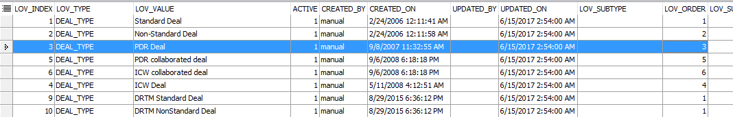

select * from CQ_DEAL where opty_number='103105844'

sol:

PDR deal that means “partner or disti or reseller created deal---a standard deal “



3 is PDR deal—so that’s how we find out

* The above **object_id** is a unique identifier for this row
* This **object_id,** when u r joining with other tables we will use this **object_id**
* in this table it called “object_id” and in other tables it is “deal_object_id”

Tables:

* CQ_DEAL ->deal level details

->what type of deal it is?

->is it a deal or standalone quote?

->who created it?

->when?

->deal source=5 change subscription deals

* CQ_LOV ->all the values for LOV columns
* CQ_QUOTE ->quote status

->if it is RNSD or not?

->if RNSD deal is attached or not

->price list details

🡪if we want to know buy method if it is 1-tier flow or 2-tier flow

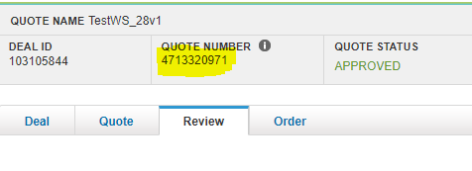

This CQ number above(Quote Number) will be the object_id

select * from CQ_QUOTE where object_id='4713320971'

sol:



If we select the price list in US dollars that id will be 1108 as above shown



This site_object_id will be refers to address or billing addresses where we cannot store full address so that’s why we will use id



To know 1-tier or 2-tier flow there is one column called “fulfillment_type”

If we select buy method as “disti” then fulfillment_type will be 2-tier



If we observe Intended use in CCW then that INTENDED_USE column will refers to this

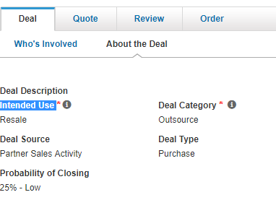



Here if its shows ‘Y’ then it is an RNSD deal. If u want u can check if u created any RNSD deal



If we add RNSD to standard deals then that deal id will be stored in this particular column show above



Here it says quote status approved i.e. .,



For quotestatus it is PDR_DEAL_STATUS.so query is

select * from cq_lov where lov_type='PDR_DEAL_STATUS'

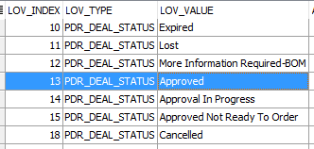

It means that if quote status is 13 then it is approved

the above object_id in other tables we will use as quote_object_id

If we want to know the quote lines we have query

select * from CQ_QUOTE_LINE where quote_object_id='4713320971'

and active=1

sol:

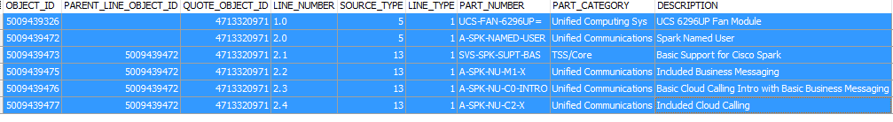

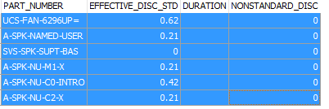

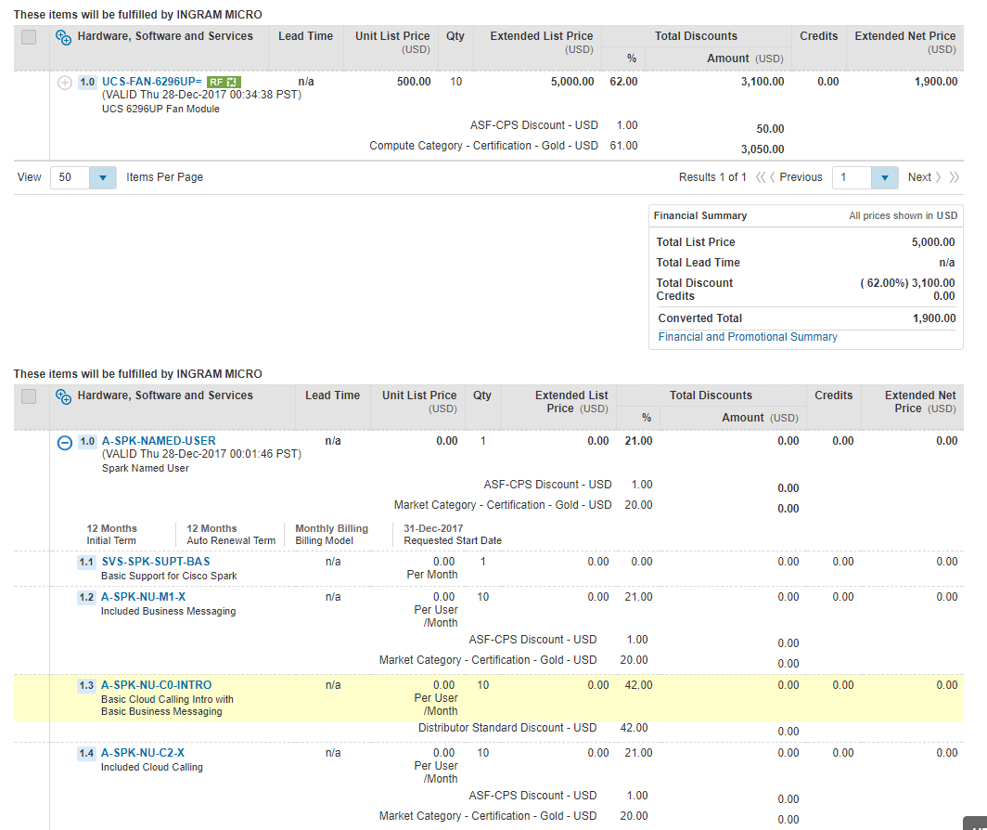

We can compare the above table and screenshot

To know the line_type that is whether added item is product or subscription

CQ_QUOTE_LINE ->line level details

->item type

1 and IS_XAAS_SKU is null or N then it is product

3 is Service

1 and IS_XAAS_SKU is Y then it is subscription

->pricing details(standard disc,NS disc)

->WEB-ORDER_ID

For more information see below diag

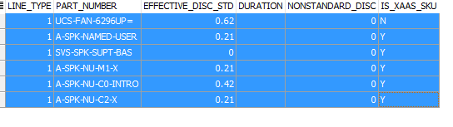

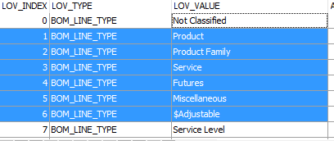

Here above u can see line types and their values

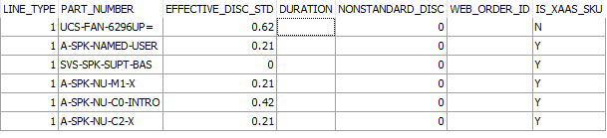

If we see in above table WEB_ORDER_ID it will be created if we create an order on top of this quote then WEB_ORDER_ID will be created in Order UI and that ID will be stored here

There is one column called UI_HIDE if that column contains Y then that item will not be displayed in the UI

If we take subscription there are some Initial term,Renewal term,start date and date date those additional line level details will be stored in “CQ_QUOTE_LINE_EXTN” table

select * from CQ_QUOTE_LINE_EXTN where QUOTE_LINE_OBJECT_ID in (select object_id from CQ_QUOTE_LINE where quote_object_id='4713320971'

and active=1)

sol:

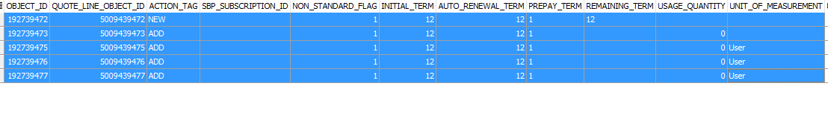

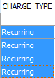

Charge_type means “usage”

Ex:if we have 1 gb data if that data got over then based on the kb’s that we consumed right it will be charged that is usage

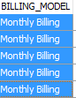

CQ_QUOTE_LINE_EXTN mainly contains---additional subscription line details that are initial term,renewal term,start date,end date etc

When u select AM or CAM that will be stored in “cq_team_assignment” table



select * from cq_team_assignment where deal_object_id='4708960011'

get deal_object_id from below query

select * from CQ_DEAL where opty_number='103105844'

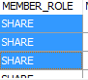

Share means

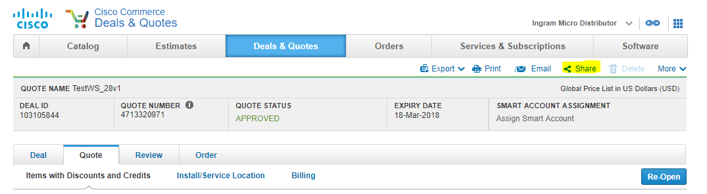

If we click that share

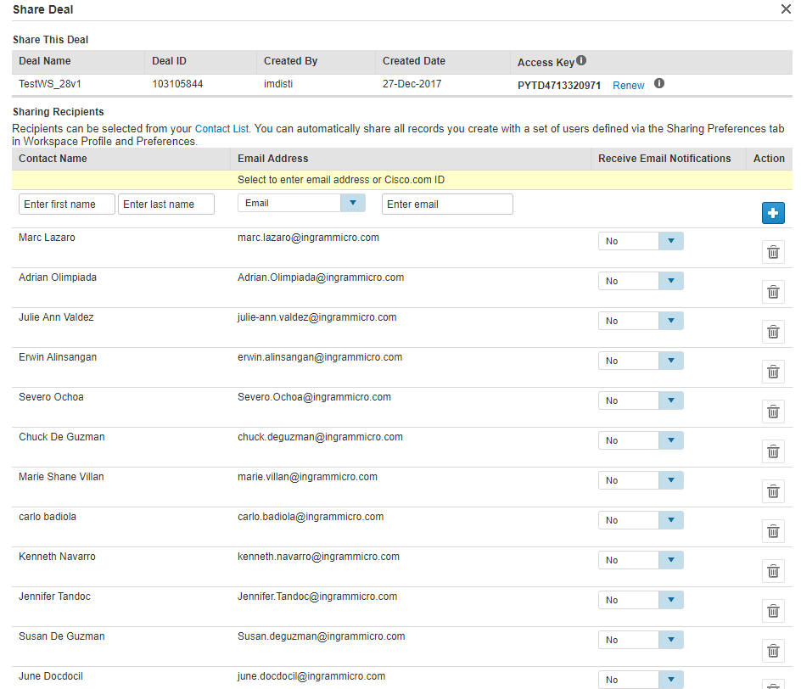

We can able to see all above data in share deal tab

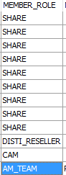

If it is AM all AM’s can be shown,

If any particular AM then only the particular AM name will be shown in the table

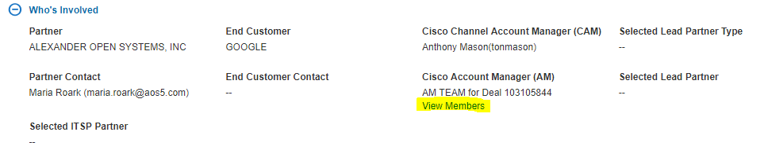

When we click “view members” below window opens with all AM’s

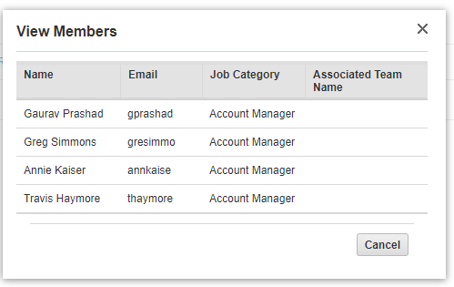

CQ_TEAM_ASSIGNMENT ->AM and CAM deal shared with whom?

CQ_AUDIT_HISTORY

select * from CQ_AUDIT_HISTORY where deal_object_id='4708960011' -



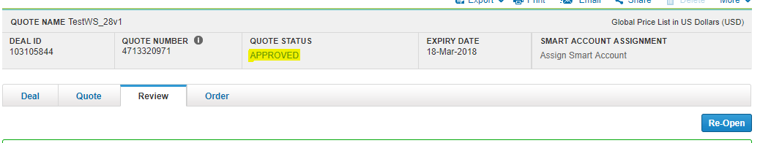so that will be triggered in the database and UI also

If we reopen it the same way it happens



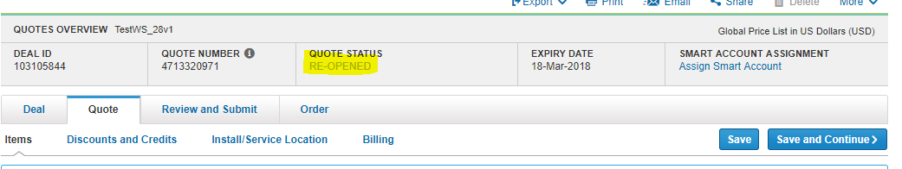

If we want to see what and all steps this deal went through you can check by clicking “view history in the “more”option

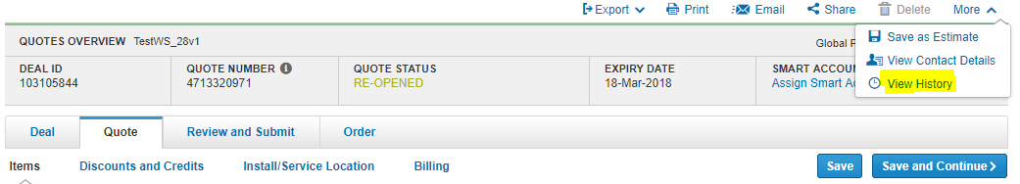

So what all steps deal has gone through will be displayed in “view history”

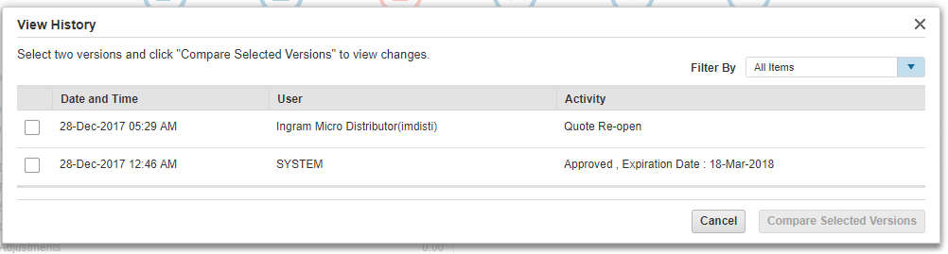

So they get it from “cq_audit_history” table

* Production deal id that we have to replicate(the onsite people will say replicate this deal)
* At that time we have to refer this cq_audit_history” and follow the steps

They would have approved it

They would have reopened it.so all the steps will be here we have to follow those steps

cq_audit_history --life cycle events of deal captured

* We didn’t see the topic in web services
* What happens when we initiate a web service
* What type of web services are called
* So we created new change subscription deal

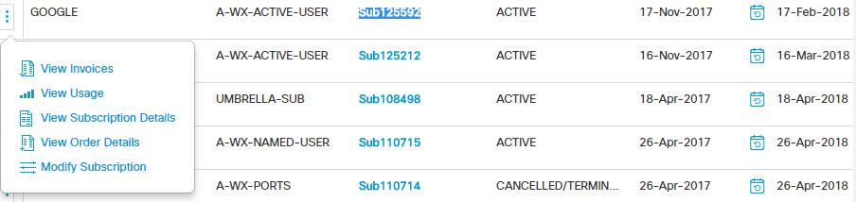

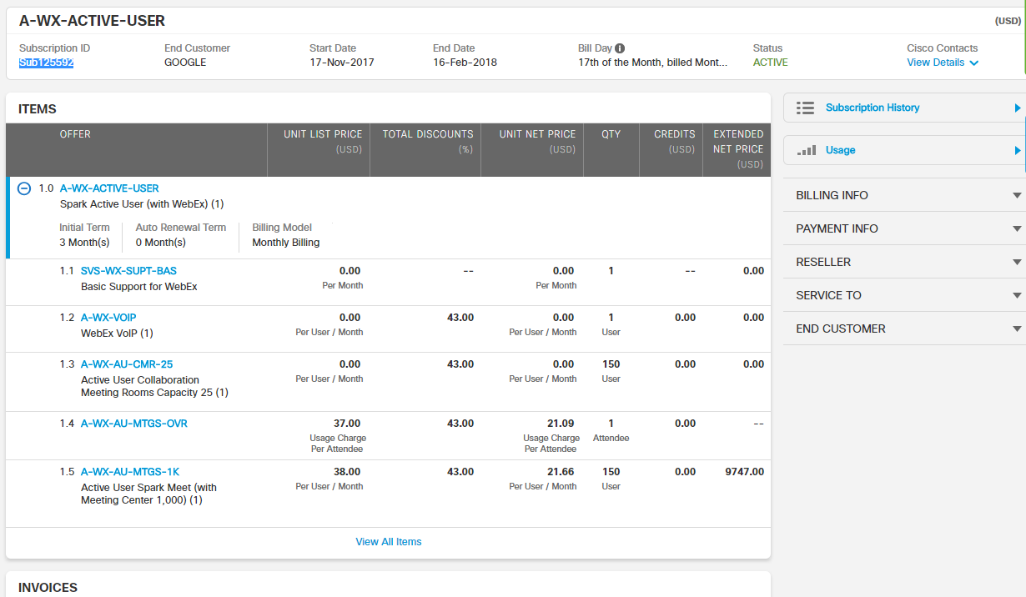

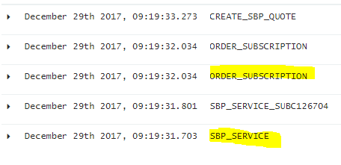

SBP_SERVICE - change subscription details from SBP

ORDER_SUBSCRIPTION – subscription details from order

**Replicate the deal**

For product deal the credentials for db are

Connect to XXAPPSRO -- username

Identified by "TPEu4F_7M" --paswd

Using 'DMPROD_RO'—db

--to view all tables starts with cq*

--change to “DMADM”

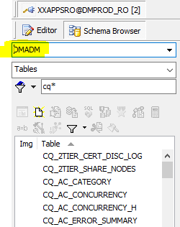

Steps to follow to replicate the deal:

1. Open URL : <https://apps.cisco.com/ICW/PDR/home.do?flow=nextgen&actionType=viewFromUrl&dealId=4709392313&qID=4713850378&typeOfDeal=5>

Credentials :slalitha and C!sco123(our credentials)

1. you will get home page as below

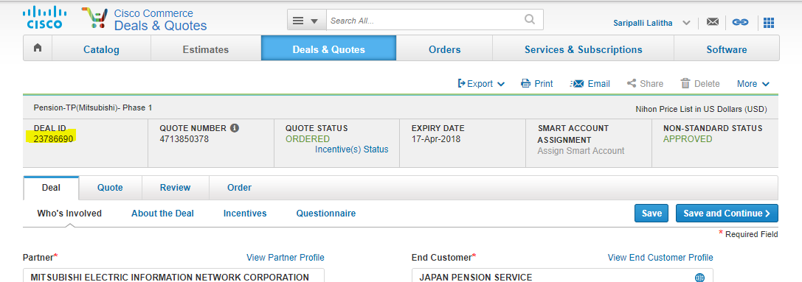

1. now with the above deal id get the details from db by using the following query and get the username to proxy with

select * from cq_deal where opty_number='23786690'

result:



So now with the user: ishikawa-daichi create the deal using proxy url

Proxy URL: <https://pdricw-cstg.cloudapps.cisco.com/ICW/PDR/proxyHome.do>

Credentials: sunchand and cisco123

Then Login as Proxy user: ishikawa-daichi

Fill all the details as mentioned in the product deal that is logged in with our credentials

Page1:

(first page of ours—product deal)

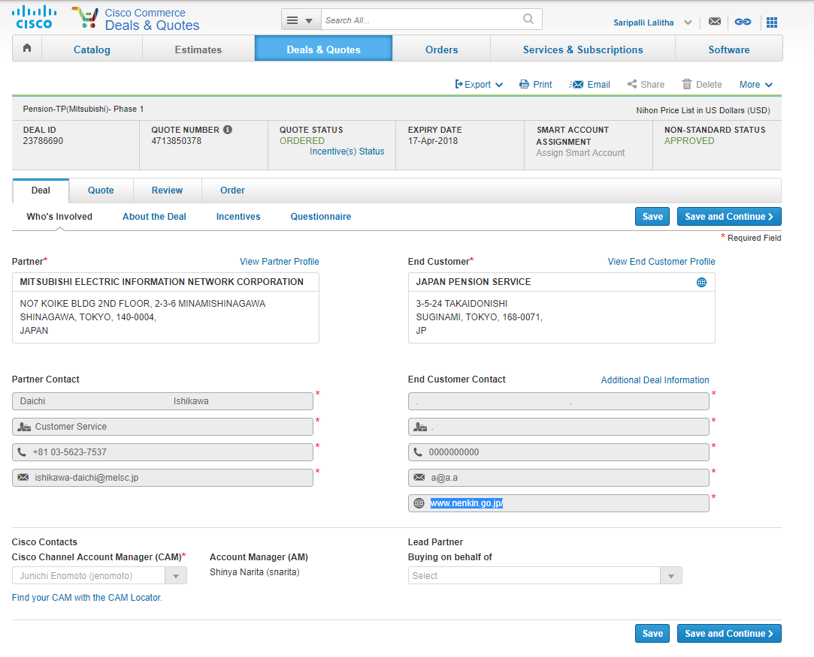

(first page of deal creator: ishikawa-daichi)

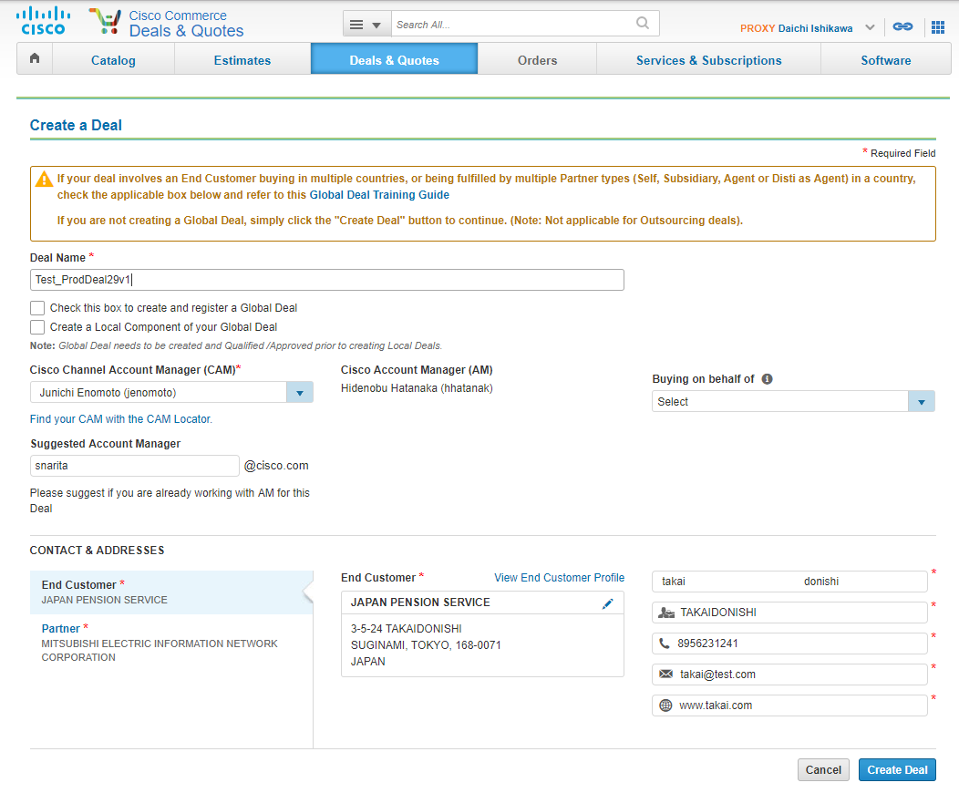

Click “create deal”

(page2—product deal)

